ONEWAY ACC BY HOS
/STATISTICS DESCRIPTIVES HOMOGENEITY WELCH
/PLOT MEANS
/MISSING ANALYSIS.

Oneway

Notes
Output Created |  | 05-May-2019 23:42:02
Comments
Input | Active Dataset | DataSet0
Input | Filter | <none>
Input | Weight | <none>
Input | Split File | <none>
Input | N of Rows in Working Data File | 30
Missing Value Handling | Definition of Missing | User-defined missing values are treated as missing.
Missing Value Handling | Cases Used | Statistics for each analysis are based on cases with no missing data for any variable in the analysis.
Syntax |  | ONEWAY ACC BY HOS  /STATISTICS DESCRIPTIVES HOMOGENEITY WELCH  /PLOT MEANS  /MISSING ANALYSIS.
Resources | Processor Time | 00 00:00:00.141
Resources | Elapsed Time | 00 00:00:00.143

[DataSet0]

Descriptives
ACC
 | N | Mean | Std. Deviation | Std. Error
Between 7-5 hours of sleep | 8 | 103.1250 | 15.90541 | 5.62341
Between 7-9 hours of sleep | 8 | 85.0000 | 25.70158 | 9.08688
Less than 5 hours of sleep | 7 | 86.0000 | 20.04994 | 7.57816
More than 9 hours of sleep | 7 | 105.4286 | 35.48172 | 13.41083
Total | 30 | 94.8333 | 25.60722 | 4.67522

Descriptives
ACC
 | 95% Confidence Interval for Mean |  | Minimum | Maximum
 | Lower Bound | Upper Bound | Minimum | Maximum
Between 7-5 hours of sleep | 89.8277 | 116.4223 | 83.00 | 123.00
Between 7-9 hours of sleep | 63.5129 | 106.4871 | 50.00 | 123.00
Less than 5 hours of sleep | 67.4569 | 104.5431 | 71.00 | 124.00
More than 9 hours of sleep | 72.6135 | 138.2437 | 57.00 | 150.00
Total | 85.2714 | 104.3952 | 50.00 | 150.00

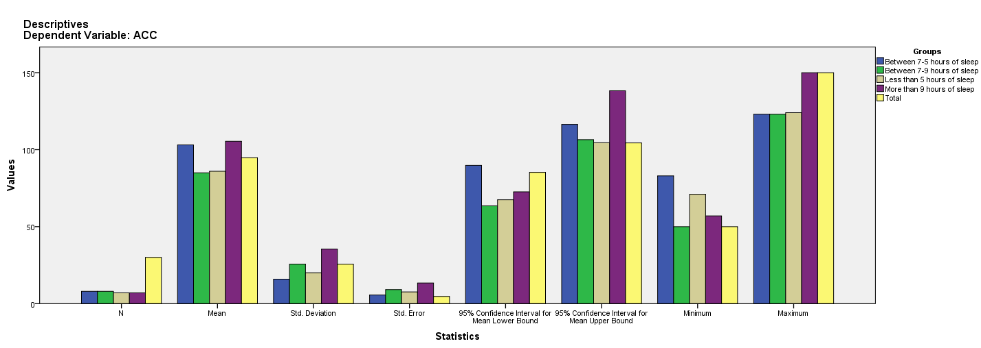

Test of Homogeneity of Variances
ACC
Levene Statistic | df1 | df2 | Sig.
3.501 | 3 | 26 | .030

ANOVA
ACC
 | Sum of Squares | df | Mean Square | F | Sig.
Between Groups | 2655.577 | 3 | 885.192 | 1.407 | .263
Within Groups | 16360.589 | 26 | 629.253
Total | 19016.167 | 29

Robust Tests of Equality of Means
ACC
 | Statisticª | df1 | df2 | Sig.
Welch | 1.607 | 3 | 13.651 | .233
a. Asymptotically F distributed.

Means Plots

